**Convert bpf file to GMNS file**

**Step 1: download bpf file from the following website**

<http://download.openstreetmap.fr/extracts/asia/china/>

**Step 2: update the latest version osm2gmns**

**Anaconda Prompt (anaconda)🡪** **pip install osm2gmns --upgrade**

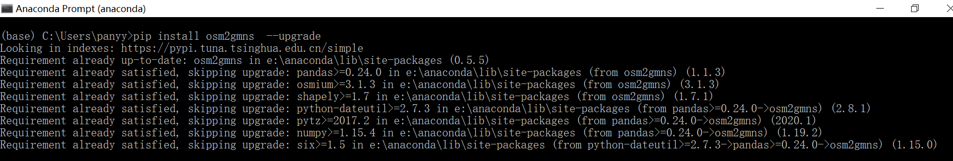

**Step 3: download parse network.py from website**

https://github.com/panyuyan/parse-network

**Step 4: modified file name, link type, POI**

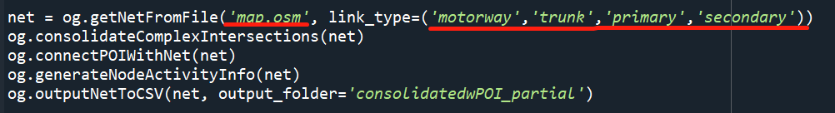

**Step 5: run parse network.py and you could get the node, link and segment csv file.**

